# Game Engines 2 – Space Battle Script

## Stargate – Battle of Asuras

## Name: Paul Kennedy

## Student Number: C10319445

## Link to the scene from the Television show: <https://www.youtube.com/watch?v=_iMHh9Utm8Y>

## Github Link for project: https://github.com/PaulKennedyDIT/Unity_SpaceBattle_Assignment_2

## Unity Asset utilised for explosions: Detonator Explosion Framework <http://u3d.as/content/ben-throop/detonator-explosion-framework/1qK>

## Opening Scene [0:00 – 00:012]

[Cue Introductory music]

Camera looks into the depths of space. Three Tauri ships emerge from hyperspace. The camera pans from left to right as the three ships pass by the camera. As the ships pass the camera eleven more ships come into view including Wraith Hive ships and Travelers Aurora class vessels.

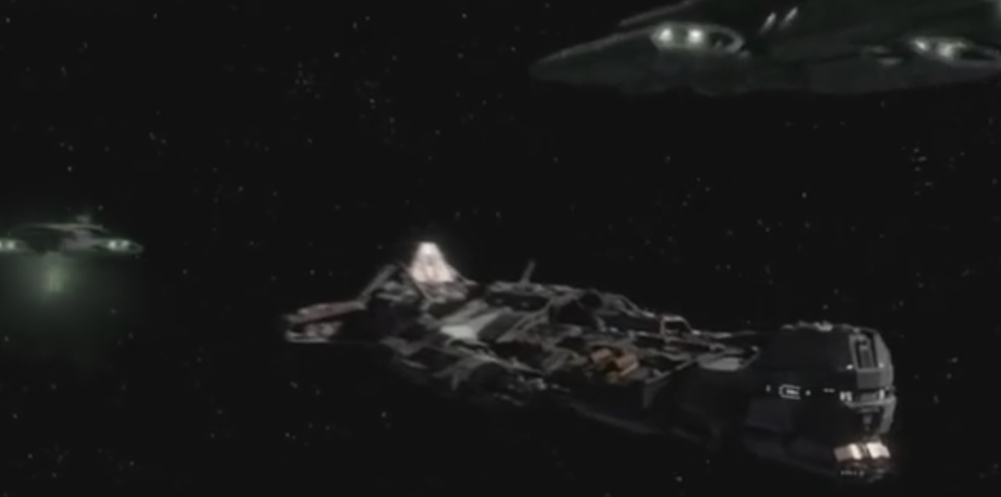

## Entering Hyperspace [00:12 – 00:17]

Starting from the right side of all the vessels pan around from right to left behind the ships. Accelerate the ships as they begin to enter hyperspace. One by one disappearing into the depths of space.

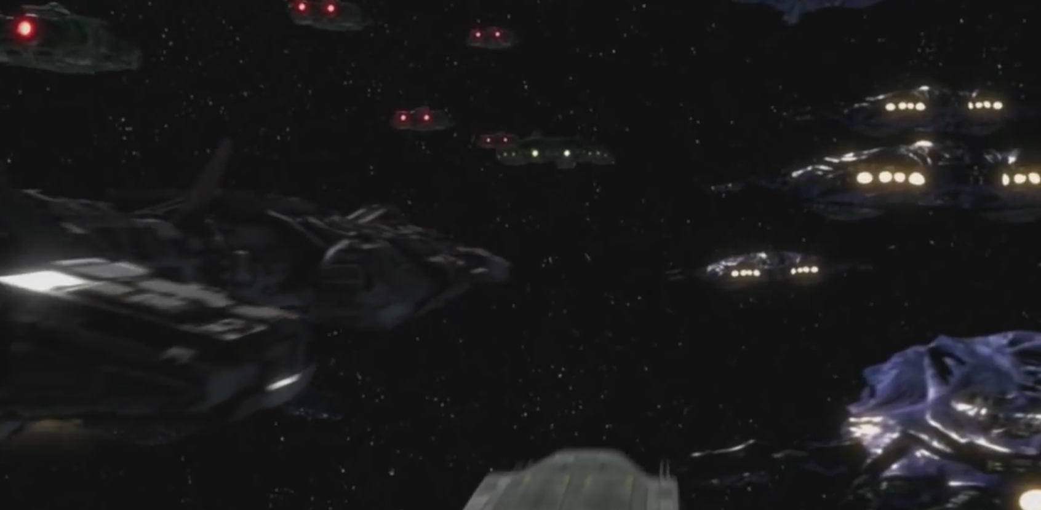

## In Hyperspace [00:17 – 00:23]

Scene opens with the camera facing the front of the Daedalus. It accelerates towards the camera and gradually passes the camera. The camera rotates to face the Daedalus as it proceeds down the hyperspace worm hole.

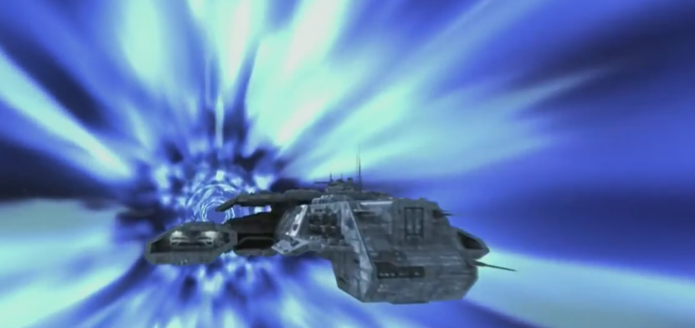

## Beginning of Space Battle [00:23 – 00:30]

Three of the eleven ships emerge from hyperspace. Instantly they begin firing at an Asauran class ship which is positioned just below the cameras location. The hull of the ship is visible. Explosions are seen on the surface of the control ship. Camera follows the Daedalus as it banks to the left, further Wraith and Traveler are seen in the background firing on Asauran vessels as the glimpse of the planet Asura comes into view. One of the Asauran ships explode in a smoked explosion whilst visible sparking explosions are seen on another Asauran ship.

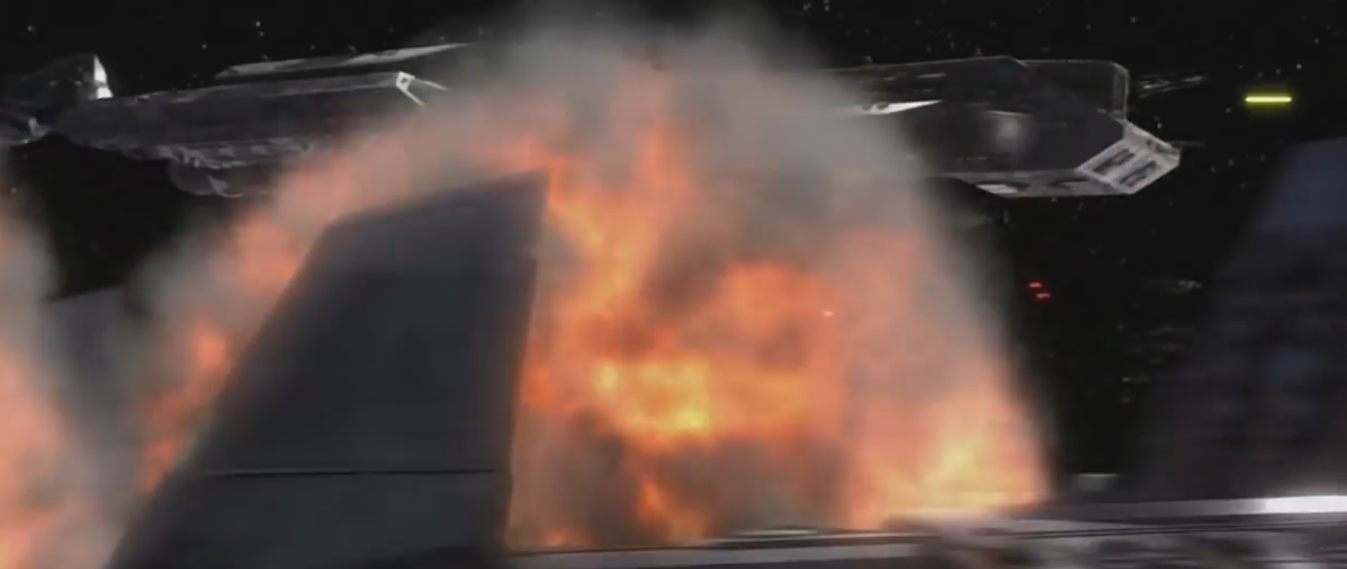

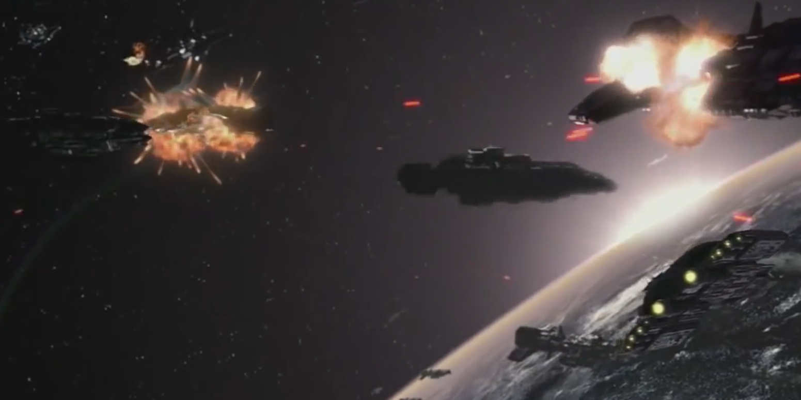

## Mid Battle Sequence [00:30 – 00:40]

Pan camera to the side of an Asauran battle cruiser. Squadron of Wraith ships fly along the starboard side of the ship. Shortly after a squadron of Tauri jets follow suit firing rockets at the Asauran ship. Explosions are seen emitting from the Asgard Battle Cruiser. The Camera inverts its position and a Wraith Hive ship is seen approaching the side of the Asauran Battle Cruiser. A multitude of lasers from both ships are fired. Explosions emit from both ships. A Tauri vessel joins the fight and fires at the Asauran ship. The Asauran ship explodes from the central core. The squadron of Tauri fighter jets double back past the screen as the camera pans from right to left again following the Tauri squadron.

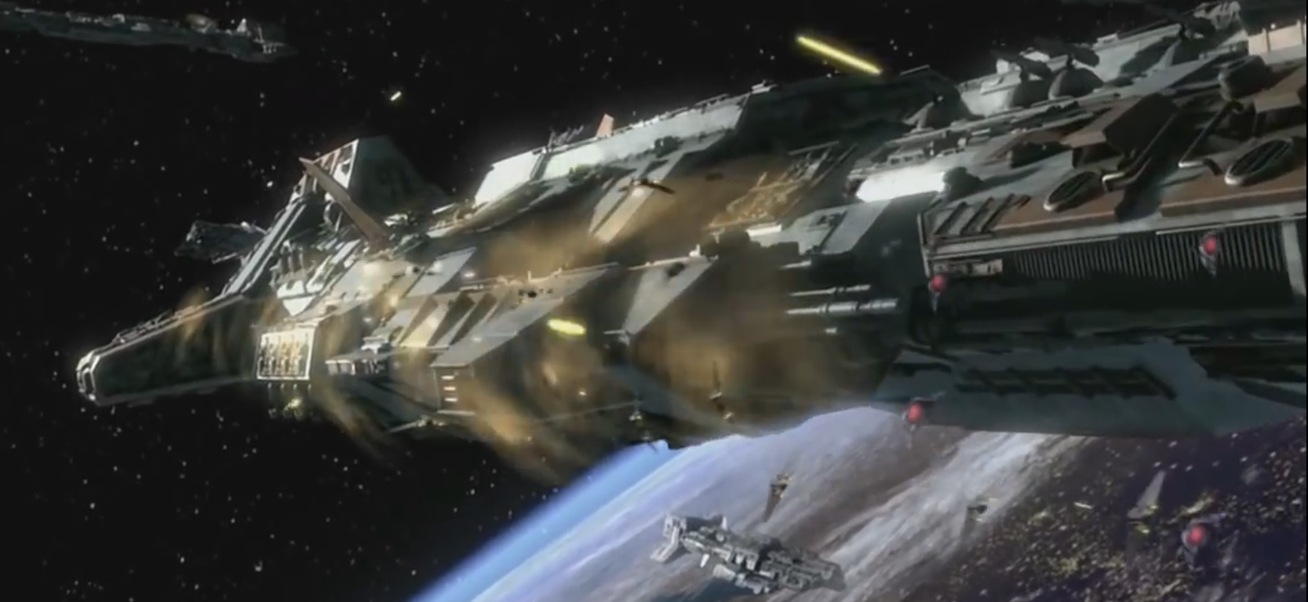

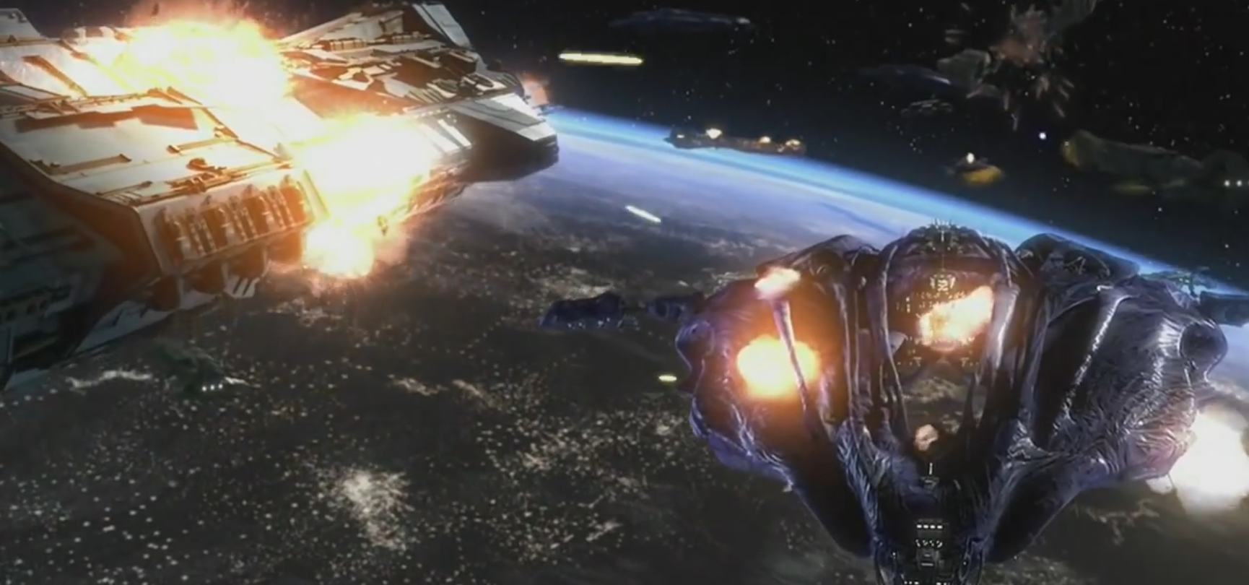

## Battle turns [01:00 – 01:14]

An Asauran battle cruiser approaches an arrangement of four Aurora battle cruisers. It is blasted from a multitude of directions. Eventually its defensive shields give in and it blows up. A further four Asauran battle cruisers begin to bombard the Aurora and Wraith hive ships. Three allied ships erupt in flames.

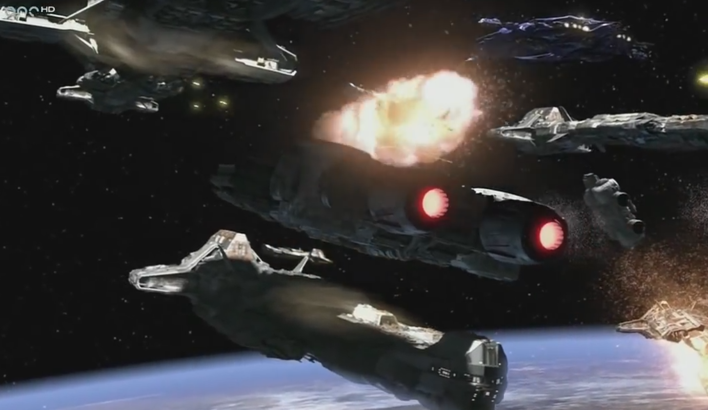

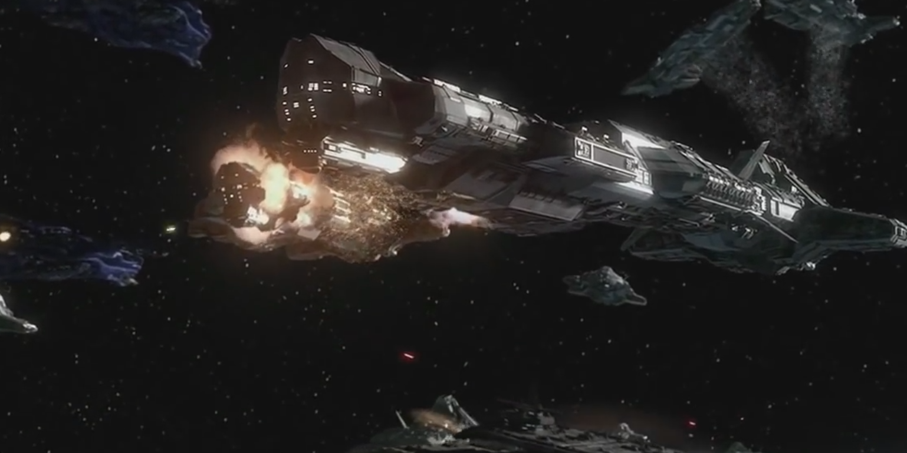

## Enter Hyperspace [01:15 – 1:25]

The planet surface begins to destabilise due to the events coinciding the space battle. The remaining Tauri, Wraith and Travelers ships disengage from the battle. They accelerate away from the vicinity of the battle area. The ships engage into hyperspace as the planet begins to implode on itself.

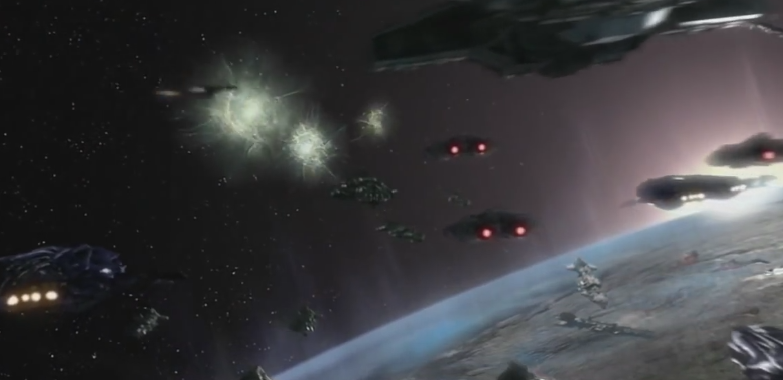

## Destruction of Asuras [1:25 – 1:30]

The camera zooms out to look at the planet from a distance. A light of growing intensity emerges from the core of the planet. The planet blows up.

